
COMSATS University Islamabad,
Abbottabad Campus

Project Proposal
(SCOPE DOCUMENT)
By
Muhammad Siraj CIIT/FA17-BSSE-124/ATD
Muhammad Farooq CIIT/FA17-BSSE-092/ATD
Muhammad Ismail CIIT/FA17-BSSE-129/ATD

Supervisor
Mateen Yaqoob

Bachelor of Science in Software Engineering (2017-2021)
No. | Comment | Action
SCOPE DOCUMENT REVSION HISTORY

Supervisor Signature
Date:

Table of Contents
1. Introduction 4
2. Problem Statement 5
3. Problem Solution for Proposed System 5
4. Related System Analysis/Literature Review 5
5. Advantages/Benefits of Proposed System 5
6. Scope 6
7. Modules 6
7.1 Module 1: Module Name 6
7.2 Module 2: Module Name 6
8. System Limitations/Constraints 6
9. Software Process Methodology 6
10. Tools and Technologies 7
11. Project Stakeholders and Roles 7
12. Team Members Individual Tasks/Work Division 8
13. Data Gathering Approach 8
14. Concepts 8
15. Gantt chart 9
16. Mockups 10
17. Conclusion 11
18. References 11
19. Plaragism Report 11

Project Category: (Select all the major domains of proposed project)
- A-Desktop Application/Information System B-Web Application/Web Application based Information System C- Problem Solving and Artificial Intelligence D-Simulation and Modeling E- Smartphone Application F- Smartphone Game G- Networks H- Image ProcessingOther (specify category) ______________________

Abstract

Facial analysis systems have become increasingly relevant to a growing number of applications. Since the recent advent of Deep Learning, particularly Convolutional Neural Networks, facial analysis tasks have been a trendy topic, as developed models are consistently breaking accuracy records on various tasks, many breaking the human-level barrier. Accurate systems have been proposed for the tasks of age estimation and gender recognition on face images, often at the expense of heavy models that require much processing power and time. The present work focuses on a solution for the two tasks deploying an efficient and fast system. To achieve this, various models derived from the same fundamental architecture were developed and compared, which perform the two tasks simultaneously on a single Convolutional Neural Network, by a Multi-task learning approach. The final models are efficient and fast, achieving successful results comparable to the Single-task models, supporting the Multi-task Learning approach.

1:Introduction
This project is about gander and age detection using mobile app

1.1 Brief Introduction
Age and gender detection using convolutional neural network is an android application.
It will detect the face in given image gender and can estimate the age of a given image.
User will upload an image using android application on backend image will be converted into an array
After all the preprocessing of an image it will pass through (CNN MODEL) model on backend which will detect the gender and estimate the age and after labeling it will send back to user using API.

1.2 Relevance to Course Modules
It comes to human interaction with computer courses, object-oriented programming, software engineering, software project management, software quality engineering, artificial intelligence and web engineering

2: Problem Statement
Age and gender, two of the key facial attributes, play a very foundational role in social interactions, making age and gender estimation from a single face image an important task in intelligent applications, such as access control, human-computer interaction, law enforcement, marketing intelligence and visual surveillance, age and gender characteristics can be applied in retail for contextual advertising for group of customers. The reliability of the existing solutions remains insufficient for practical application. The present dissertation seeks to propose a new framework of a single Convolutional Neural Network for the simultaneous tasks of age estimation and gender recognition on face images. With the purpose of being able to perform all two tasks in a single network, a multi-task learning architecture is used, jointly learning the various tasks. Using a baseline Convolutional Neural Network architecture, modifications are made to incorporate the two tasks, changes are made to the baseline architecture processes and layers, and various loss functions are considered. This has the objective of attaining an efficient and fast Multi-task working model. Various models are created with different shared layers across tasks, evaluating and comparing them on a test set. The final models should be able to provide insights on a face image concerning the age of the individual outputted in a real valued variable, the emotion of the individual outputted in one of seven classes (anger, disgust, happiness, fear, surprise, sadness and neutrality), and the gender of the individual outputted in one of two classes (male or female).

Problem Solution for Proposed System

we will use Deep Learning to accurately identify the gender and age of a person from a single image of a face.

User will upload the image using mobile app on server image will passes through the trained model which will detect the gender and estimate the age then image will labeled image using OpenCV and then it sand back to the user through REST API.
the predicted gender may be one of ‘Male’ and ‘Female’, and the predicted age may be one of the following ranges- (0 – 2), (4 – 6), (8 – 12), (15 – 20), (25 – 32), (38 – 43), (48 – 53), (60 – 100) (8 nodes in the final SoftMax layer). It is very difficult to accurately guess an exact age from a single image because of factors like makeup, lighting, obstructions, and facial expressions. And so, we make this a classification problem instead of making it one of regression.
The CNN Architecture The convolutional neural network for this python project has 3 convolutional layers:
Convolutional layer; 96 nodes, kernel size 7 Convolutional layer; 256 nodes, kernel size 5 Convolutional layer; 384 nodes, kernel size 3
It has 2 fully connected layers, each with 512 nodes, and a final output layer of SoftMax type.
To go about the python project, we’ll Detect faces Classify into Male/Female Classify into one of the 8 age ranges Put the results on the image and display it.

Related System Analysis/Literature Review
Write about the existing/similar systems related to your proposed project. At least three existing systems should be discussed.
Don’t use more than 4 sentences for explaining a single system/application.
Briefly explain the related system analysis which help to specify the contribution of the proposed project.
(Note: Research based projects may provide literature review instead of related system analysis.)

Table 1 Related System Analysis with proposed project solution
Application Name | Weakness | Proposed Project Solution
The name of related application(s). | Weaknesses may include limited features, low quality functionality and processes. | The way the proposed project mitigates the weaknesses.

Advantages/Benefits of Proposed System
W t

Scope
Age and Gender detector is an android based mobile application. User can detect gender and age using this application. User will upload the image using android mobile app. Age and gender detection model on the backend will detect the age and gender. The predicted gender may be one of ‘Male’ and ‘Female’, and the predicted age may be one of the following ranges- (0 – 2), (4 – 6), (8 – 12), (15 – 20), (25 – 32), (38 – 43), (48 – 53), (60 – 100).

Modules
There are two modules exist in project these modules are:

Module 1: Android application

Module 1: backend module

Module 1: Android application:

Android Mobile application will contain user friendly user interface using this application user will upload the image to backend there will two options for user to upload any image.
User can take new picture using android phone camera and also select any image from android mobile gallery after the selecting the image it will show to using image View after the confirmation of the user it will uploaded to the server using REST API.
Server response will be shown to user using android mobile app.

Module 2: backend module:

Backend module will contain the deep learning model the uploaded image will be passed through the deep learning model it will detect the age and gender then it will be labeled using OpenCV and send it back to mobile app using the REST API.

System Limitations/Constraints

System will be available to use 24/7. Offline user can do nothing Android application will be available. The language used in the applications will be English.

Software Process Methodology
Object-oriented methodology will be used in this project. In the object-oriented methodology, the focus is on the modules that combines process and data together. The goal of the object-oriented methodology is to make improvements in program quality and productivity. During analysis object-oriented methodologies are used that fill gap between solutions and problems.
Tools and Technologies
Mention all the hardware/software tools and technologies with version number which will be used in implementation of the project. Write about the APIs, language(s), SDK(s) etc. which you will use for implementation.

Table 2Tools and Technologies for Proposed Project
Tools  And  Technologies | Tools | Version | Rationale
Tools  And  Technologies | Android studio | 4.0 | IDE
Tools  And  Technologies | PyCharm | 2020.2.3 | IDE
Tools  And  Technologies | Adobe XD | version 32.0 | Design Work
Tools  And  Technologies | MS Word | 2015 | Documentation
Tools  And  Technologies | MS Power Point | 2015 | Presentation
Tools  And  Technologies | Pencil | - | Mockups Creation
Tools  And  Technologies | Django | 3.0 | framework
Tools  And  Technologies | Django Rest Framework | 3.11 | framework
Tools  And  Technologies | TensorFlow | 1.15 | library
Tools  And  Technologies | OpenCV | 4.5. 0 | library
Tools  And  Technologies | Technology | Version | Rationale
Tools  And  Technologies | python | 3.8. 0 | Programming language
Tools  And  Technologies | java | 15.0. 1 | Programming language

Project Stakeholders and Roles
Write down the project stakeholders and their roles.

Table 3Project Stakeholders for Proposed Project
Project Sponsor | COMSATS University, Islamabad
Stakeholder | Development team  - Project Supervisor Name: Mr. Mateen Yaqoob  - Final Year Project Committee: Evaluation of project

Team Members Individual Tasks/Work Division
Table 4Team Member Work Division for Proposed Project
Student Name | Student Registration Number | Responsibility/ Modules
Muhammad Ismail  Muhammad Siraj  Muhammad Farooq | FA17-BSE -127  FA17-BSE - 124  FA17-BSE - 092

Data Gathering Approach
- Write Existing age and gender detection application are being analyzed thoroughly and their weaknesses are exposed via users feedback .this is going to help us in developing our application which is going to tackle all deficiencies highlighted in the existing application.
- Observing and research document are discussed mutually among group members and deciding implementation strategy for all levels is finalized

Concepts
Mention the concepts that you will learn while doing the proposed project.
For example: Augmented Reality, Virtual Reality, Algorithms, API’’s Code injection, Closures, VI technique etc.
Not more than 4 sentences for one concept. (Usually 3-5 concepts are briefly mentioned)

Example:

Concept-1: Concept Name E.g. Augmented Reality (Briefly give the overview of concept with respect to your project)

Gantt chart
Create the Grant Chart and provide estimated start and end dates of all proposed modules/tasks for each team member. Also identify the dependencies (which tasks cannot be started/completed, until the dependent task is completed). Gantt chart can be created using MS Project.
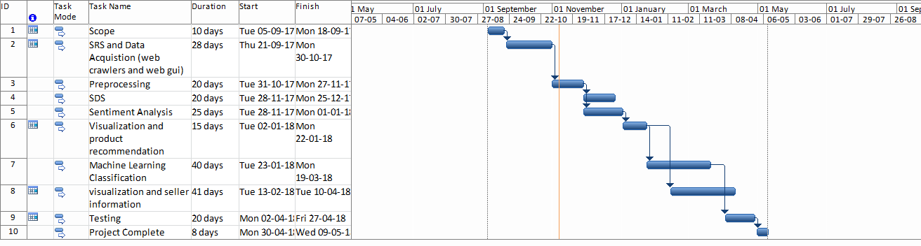
Figure 1Sample Gantt chart

Mockups
Insert minimum mockups (Usually 4-6 mockups) which show the major modules mentioned in the scope section of the document. Do not include mockups for Login, Signup, Forgot Password, Contact Us, About Us etc. If the project is a Web or a Smartphone Application, then include at-least three mockups from each part of the project. You can design mockup in any design tool for example pencil tool (https://pencil.evolus.vn/) or Balsamiq (https://balsamiq.com/)

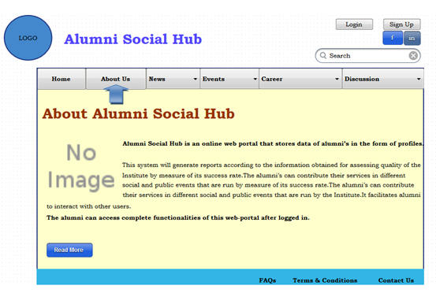

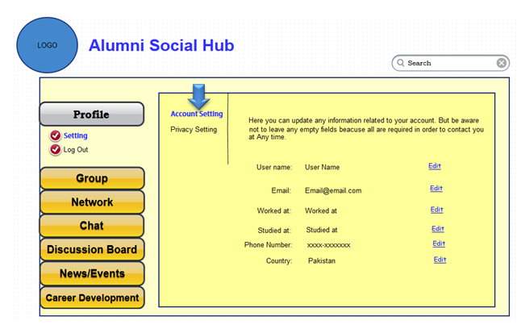

Conclusion
Conclude this document. (Usually 4-5 sentences)

References
Mention the books, research papers, web links etc.

Plagiarism Report
Attach the Plagiarism report of your project scope document from library staff of turnitin tool (http://turnitin.com

